**CHAPTER 4**

**INFORMATION DISPLAY WITH RADIO FREQUENCY IDENTIFICATION INTEGRATION SOFTWARE DEVELOPMENT**

This chapter focuses on the different user interfaces, database relationships of the system, the flow proper of the system, system specifications, system requirements, system assumptions and system constraints in developing the information display with radio frequency identification integration.

**4.1 Requirement Specification**

**4.1.1 Business Flow**

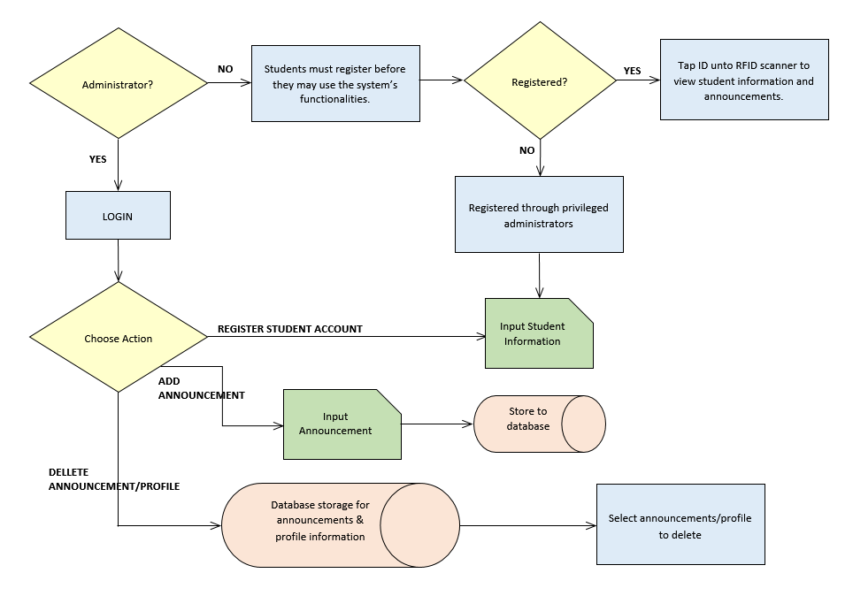

*Figure 4.1 Business Flow Chart*

In Figure 4.1, it shows the whole process of the system. There are two users in the system, the administrators and the users (students). When an administrator logs-in, he or she has actions to choose from, he or she can register, update, and delete a student. He or she can also add general announcements intended to all students or he or she can specify these announcements according to year level. And he or she can delete and update a specific announcement. In the user’s section, he or she has to verify whether he or she is already registered. If he or she is registered, he or she can directly view announcements and other information about his or her profile. If not, he or she has to register to privileged administrators.

**4.1.2 System Interfaces**

**Admin Module.** This module could create a student and an administrator account. It could delete and update a student account. It could also add and post announcements for the students and it could delete and update publications as well.

**User Module.** This module will let the students view their own student profile and information. It could also let them view important announcements according to their year level.

**4.1.3 User Interfaces**

**Login Module**

The Login Module can only be accessed by privileged users, i.e. the Administrators, who can then input their registered username and password to access their accounts.

**User-Level: Administrator**

**Create Administrator Account**

A function button is located on the administrator page which directs the user to a form page where the administrator can input information regarding the new administrator account to be created such as the username, password, and position of administrator (section coordinator, faculty, teacher, or student council officer).

**Register Student Account**

A function button is located on the administrator page which directs the user to a form page where the administrator can input information regarding the new student account to be created such asthe student’s name, program, and year-level. Here, the administrator will also be able to register the student’s RFID to integrate with his/her record.

**Add Announcements**

A function button is located on the administrator page which directs the user to a form page where the administrator can input information regarding important announcements he/she wishes to post unto the system. These information includes but is not limited to the date, venue, etc. The administrator may also choose to filter students whom he/she wishes the announcement to directly be posted to.

**Delete Student Account**

A function button is located on the student accounts list page that deletes a specific student account. If the button is clicked, it first verifies with the user administrator whether he/she will proceed with the deletion of the student account.

**Delete Announcement**

A function button is located on the announcements list page that deletes a specific announcement. If the button is clicked, it first verifies with the user administrator whether he/she will proceed with the deletion of the announcement.

**Update Student Account**

A function button is located on the administrator page which directs the user to a form page where the administrator can update an already registered student account’s information should the need arise.

**Update Announcement**

A function button is located on the administrator page which directs the user to a form page where the administrator can update an already posted announcement should the need arise.

**Search Student Account**

This page will display every available student account in table-form. A search bar can be located on the upper-right hand corner of the page where an administrator can input information and a list of students accounts that match the search query will list down.

**Search Announcement**

This page will display every available posted announcement in table-form. A search bar can be located on the upper-right hand corner of the page where an administrator can input information and a list posted announcements that match the search query will list down.

**User-level: Student**

**View Student Information**

This page will display every available information regarding the logged-in user. Information will include whether he or she has already paid his/her student organization’s membership fee, and any other miscellaneous fees that need to be settled.

**View Year Level Announcements**

This page will display every available information in table-form with respect to the logged-in user’s year-level.

**View Announcement Details**

Upon choosing a specific announcement to view, the user will be able to read every available information and detail regarding that specific announcement.

**4.1.4 Hardware Interfaces**

This section describes the hardware aspect and interfaces that have been utilized throughout the development cycle of the system project.

Several laptops and a desktop personal computer were used by the developers throughout the system development phase and creation of documentation files. An RFID reader was used by the developers to test the RFID integration of the system.

**4.1.5 Software Interfaces**

This section describes the software applications and software interfaces that have been utilized throughout the development cycle of the system project.

**Git** is a free and open source distributed version control system designed to handle everything from small to very large projects with speed and efficiency. (Git, 2015)

**BitBucket** is a web-based hosting service for projects that use either the Mercurial (since the origin) or Git (since October 2011[1]) revision control systems. (Wikipedia, 2015)

**ZURB Foundation** is a free collection of tools for creating websites and web applications. It contains HTML and CSS-based design templates for typography, forms, buttons, navigation and other interface components, as well as optional JavaScript extensions. (Wikipedia, 2015)

**XAMPP** is a free and open source cross-platform web server solution stack package, consisting mainly of the Apache HTTP Server, MySQL database, and interpreters for scripts written in the PHP and Perl programming languages. (Wikipedia, 2015)

**CodeIgniter** is an open source rapid development web application framework, for use in building dynamic web sites with PHP. (Wikipedia, 2015)

**Sublime Text** is a cross-platform text and source code editor, with a Python application programming interface (API). (Wikipedia, 2015)

**PHP** is a server scripting language, and a powerful tool for making dynamic and interactive Web pages. (W3Schools, 2015)

**CSS** is a style sheet language used for describing the look and formatting of a document written in a markup language. (Wikipedia, 2015)

**JavaScript** is a dynamic computer programming language. It is most commonly used as part of web browsers, whose implementations allow client-side scripts to interact with the user, control the browser, communicate asynchronously, and alter the document content that is displayed. (Flanagan & Ferguson 2006)

**jQuery** is a cross-platform JavaScript library designed to simplify the client-side scripting of HTML. (The jQuery Project)

**HTML** is the standard markup language used to create Web pages. (Wikipedia, 2015)

**Adobe Photoshop** is a raster graphics editor developed and published by Adobe Systems for Windows and OS X. (Wikipedia, 2015)

**4.1.6 Communication Interfaces**

This section describes the software applications and software interfaces that have been utilized throughout the development cycle of the system project.

**Local Area Network (LAN)** is used to access the system. Internet is needed to open the web pages necessary for the use of the system. A web host or web server is also needed to host the files of the system.

**4.1.7 User Characteristics**

The system’s users will include the students, as well as the faculty members, section coordinators, and the chairman of the Department of Computer Science of the University of San Carlos. The students make up the user-level entity of the system. Provided they have their school ID with an RFID chip integrated in it, the students can register themselves unto the system via a system administrator and use the functionalities made available to the student. Upon logging into the system with a tap of their school ID’s on the RFID reader, the students have the ability to read any general announcements and information that pertain to their program and year-level, as well as any direct announcements from a faculty member to that specific student. Students may also view their student profiles and verify whether they have any fees that need settling for the semester.

The administrator-level or privileged users have added functionalities that are available to him/her upon logging unto the system via a username and password determined upon the creation of their account. Privileged users include the chairperson, section coordinators, faculty members and selected student organization officers of the Department of Computer Science. Added functionalities include the ability to write, read, and delete announcements and general information displayed by the system, as well as retrieving data from the database.

**4.1.8 Constraints**

The system can only be accessed by students and faculty members who belong to the Department of Computer Science of the University of San Carlos. The developers are not responsible for the deployment of the system within the campus.

**4.1.9 Assumptions and Dependencies**

The system will assume that the following requierements and dependencies will have been met before the system will be utilized and used in any manner:

1. All enrolled students of the Department of Computer Science have functioning school ID’s with RFID chips integrated into them.

2. Information gathered pertaining the registered students of the Department of Computer Science are secured.

3. Users of the system will be properly instructed on the proper usage of the system and its hardware.

**4.1.10 Specific Requirements**

**Functional Requirements**

1. **Student Log in**

***Table 4.1 Student***

|  |  |  |  |
| --- | --- | --- | --- |
| Requirement ID | Description | Priority | Approved/  Confirmed by |
| REQ-001 | The homepage will be displayed when no user-interaction is made | 1 | Mary Jane Sabellano |
| REQ-002 | There will be a display a carousel of general information | 1 | Mary Jane Sabellano |
| REQ-003 | When a student taps their ID unto the RFID scanner, the system logs the user in based on their registered RFID | 1 | Mary Jane Sabellano |
| REQ-004 | If a student’s ID is not registered unto the system, a student must approach an administrator to register his ID | 1 | Mary Jane Sabellano |
| REQ-005 | Upon logging in, the student’s information will display unto the screen alongside the content area | 1 | Mary Jane Sabellano |
| REQ-006 | There will be a button that when clicked will display the general information on the content area | 1 | Mary Jane Sabellano |
| REQ-007 | There will be a button that when clicked will display information pertaining to an organizational-level | 1 | Mary Jane Sabellano |
| REQ-008 | There will be a button that when clicked will display information pertaining to the user’s year-level | 1 | Mary Jane Sabellano |
| REQ-009 | When a user clicks a specific announcement, the announcement’s full details will be displayed | 1 | Mary Jane Sabellano |

1. **Faculty Log in**

***Table 4.2 Faculty/Administrator***

|  |  |  |  |
| --- | --- | --- | --- |
| Requirement ID | Description | Priority | Approved/  Confirmed by |
| REQ-001 | The login page will be displayed as the landing page | 1 | Mary Jane Sabellano |
| REQ-002 | When the user inputs their login details, the system will log the user in and present different functionalities | 1 | Mary Jane Sabellano |
| REQ-003 | If an administrator does not have a user account, another administrator may register him/her to the system | 1 | Mary Jane Sabellano |
| REQ-004 | The user will be able to register a student along with his ID with RFID built-in into the system | 1 | Mary Jane Sabellano |
| REQ-005 | The user will be able to search for a specific student account that have already been registered into the system | 1 | Mary Jane Sabellano |
| REQ-006 | The user will be able to update a student’s account and information | 1 | Mary Jane Sabellano |
| REQ-007 | The user will be able to delete a student account and all his details from the system | 1 | Mary Jane Sabellano |
| REQ-008 | The user will be able to post a new announcement or information post into the system | 1 | Mary Jane Sabellano |
| REQ-009 | The user will be able to search through posts and announcements that have already been uploaded into the system | 1 | Mary Jane Sabellano |
| REQ-010 | The user will be able to update an already posted announcements details and information into the system | 1 | Mary Jane Sabellano |
| REQ-011 | The user will be able to delete an announcement from the system that has already been posted | 1 | Mary Jane Sabellano |